CITY OF NOWTHEN 8188 199th Ave NW
Nowthen, MN 55330
Phone: 763-441-1347

PLEASE CALL MNSPECT (952)442-7520
for inspections

SSTS PERMIT

Routed to MNSPECT

LEGAL:

Address:
State: MN Zip_: Email: Phone:

COPY OF SITE EVALUATION AND SYSTEM DESIGN MUST BE ATTACHED
Address:
State: MN Zip_: Phone: State License #:
Address:
State: MN Zip_: Phone: State License #:
App_licant Contact Name: Phone: Email:

SYSTEM INFORMATION:
CONSTRUCTION TYPE: □NEW □ALTERATION/REPLACEMENT □TANK/PUMP ONLY (circle one) □REPAIR

TYPE OF SEPTIC SYSTEM: □Type I □Type II

□Standard Trenches □Mound
□Type Ill □Type IV

□Pressure Bed
□Type V

□Other: _

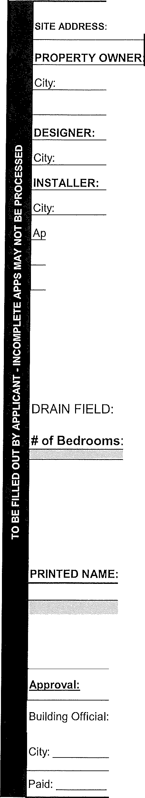
GPO: # of Tanks Installed: # of Existing Tanks:

Signature of this application by the legal property owner or a licensed contractor, as the owner's representative, is required and authorizes the Zoning Administrator or designee and the Building Official or d:3dr.e toe:nt:r upon the property to perform needed inspections. Entry may be without prior notice. I hereby acknowledge that I have read this application and state that all information is true and correct to the best of my TN'Nl-e::f-Qi:. I further agree that all work performed will be in accordance with approved plans, specifications and conditions and to abide by all ordinances of the Municipality and the laws of the State of Minnesota regard\r,g acfuns tlke:n pursuant to this permit. I agree to pay all fees even if I choose not to proceed with the work. Permit expires when work is not commenced within 180 days from date of permit, or if work is suspended, abar.-O,e,r:e-j, or rc0t inspected for 180 days. Work beyond the scope of this permit, or work without a permit or inspection, wilt be subject to a penalty. ALL WORK SHALL BE DONE IN ACCORDANCE WITH APPLICABLE PORTIONS OF MN RULES CHAPTER 7080 THROUGH 7083

SIGNATURE OF APPLICANT: DATE: _
This is the signature of:□Owner or □Owner's Representative

OFFICE USE ONLY:

DATE ALL REQUIRED INFORMATION WAS RECEIVED: _

DATE: PERMIT FEE: DATE:
Date: _ Receipt No. _ By:

